**Proyecto Final**

**Códigos del proyecto en html.**

**Estructura html**

**<!DOCTYPE html>**

**<html>**

**<head>**

**<link rel="stylesheet" href="https://cdn.jsdelivr.net/npm/bootstrap@4.5.3/dist/css/bootstrap.min.css" integrity="sha384-TX8t27EcRE3e/ihU7zmQxVncDAy5uIKz4rEkgIXeMed4M0jlfIDPvg6uqKI2xXr2" crossorigin="anonymous">**

**</head>**

**<body>**

**<form>**

**<div class="container">**

**<div class="abs-center">**

**<form action="#" class="border p-3 form">**

**<div class="form-group">**

**<h1>Accede como candidato</h1>**

**<div class="form-group">**

**<label for="exampleInputEmail1">Email</label>**

**<input type="email" class="form-control" id="exampleInputEmail1" aria-describedby="emailHelp" name="nombre"required>**

**<small id="emailHelp" class="form-text text-muted"></small>**

**</div>**

**<div class="form-group">**

**<label for="exampleInputPassword1">Contraseña</label>**

**<input type="password" class="form-control" id="exampleInputPassword1" name="nombre"required>**

**</div>**

**<div class="form-group form-check">**

**<input type="checkbox" class="form-check-input" id="exampleCheck1" name="nombre"required>**

**<label class="form-check-label" for="exampleCheck1">Mantener mi sesión abierta</label>**

**<label for="exampleFormControlFile1">Más Info</label>**

**<br>**

**<button type="submit" class="btn btn-primary">INICIA SESIÓN</button></br>**

**</div>**

**<div class="form-group">**

**<label for="password">Password</label>**

**<input type="password" name="password" id="password" class="form-control">**

**</div>**

**</form>**

**</div>**

**</div>**

**</form>**

**</body>**

**</html>**

**Imagen de la estructura de html para el proyecto**

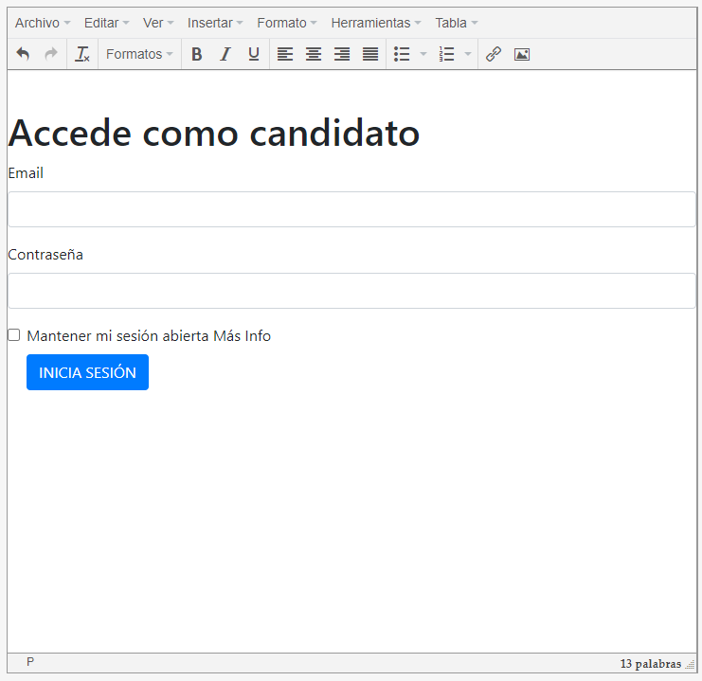

**En todos los inputs debo hacer los name (name="nombre"required>)**

**en todos los form (action="" method="post"novalidate>)**

**esto se debe ser porque es necesario para que se envie la informacion a un archivo donde se recoge como una base de datos**

**Estructura Html**

**<!DOCTYPE html>**

**<html>**

**<head>**

**<link rel="stylesheet" href="https://cdn.jsdelivr.net/npm/bootstrap@4.5.3/dist/css/bootstrap.min.css" integrity="sha384-TX8t27EcRE3e/ihU7zmQxVncDAy5uIKz4rEkgIXeMed4M0jlfIDPvg6uqKI2xXr2" crossorigin="anonymous">**

**</head>**

**<body>**

**<form class="needs-validation" action="" method="post"novalidate>**

**<div class="form-row">**

**<div class="col-md-6 mb-3">**

**<label for="validationCustom01">Nombre</label>**

**<input type="text" class="form-control" id="validationCustom01" name="nombre"required>**

**<div class="valid-feedback">**

**Looks good!**

**</div>**

**</div>**

**<div class="col-md-6 mb-3">**

**<label for="validationCustom02">Apellidos</label>**

**<input type="text" class="form-control" id="validationCustom02" required>**

**<div class="valid-feedback">**

**Looks good!**

**</div>**

**</div>**

**</div>**

**<div class="form-row">**

**<div class="col-md-6 mb-3">**

**<label for="validationCustom03">Ciudad</label>**

**<input type="text" class="form-control" id="validationCustom03" required>**

**<div class="invalid-feedback">**

**Please provide a valid city.**

**</div>**

**</div>**

**<div class="col-md-3 mb-3">**

**<label for="validationCustom04">Municipio</label>**

**<select class="custom-select" id="validationCustom04" required>**

**<option selected disabled value="">Choose...</option>**

**<option>...</option>**

**</select>**

**<div class="invalid-feedback">**

**Please select a valid state.**

**</div>**

**</div>**

**<div class="col-md-3 mb-3">**

**<label for="validationCustom05">Codigo postal</label>**

**<input type="text" class="form-control" id="validationCustom05" name="nombre"required>**

**<div class="invalid-feedback">**

**Please provide a valid zip.**

**</div>**

**</div>**

**</div>**

**<div class="form-group">**

**<div class="form-check">**

**<input class="form-check-input" type="checkbox" value="" id="invalidCheck" name="nombre"required>**

**<label class="form-check-label" for="invalidCheck">**

**Agree to terms and conditions**

**</label>**

**<div class="invalid-feedback">**

**You must agree before submitting.**

**</div>**

**</div>**

**</div>**

**<button class="btn btn-primary" type="submit">Submit form</button>**

**</form>**

**<script>**

**// Example starter JavaScript for disabling form submissions if there are invalid fields**

**(function() {**

**'use strict';**

**window.addEventListener('load', function() {**

**// Fetch all the forms we want to apply custom Bootstrap validation styles to**

**var forms = document.getElementsByClassName('needs-validation');**

**// Loop over them and prevent submission**

**var validation = Array.prototype.filter.call(forms, function(form) {**

**form.addEventListener('submit', function(event) {**

**if (form.checkValidity() === false) {**

**event.preventDefault();**

**event.stopPropagation();**

**}**

**form.classList.add('was-validated');**

**}, false);**

**});**

**}, false);**

**})();**

**</script>**

**</form>**

**</body>**

**</html>**

**Imagen de la estructura de html para el proyecto**

